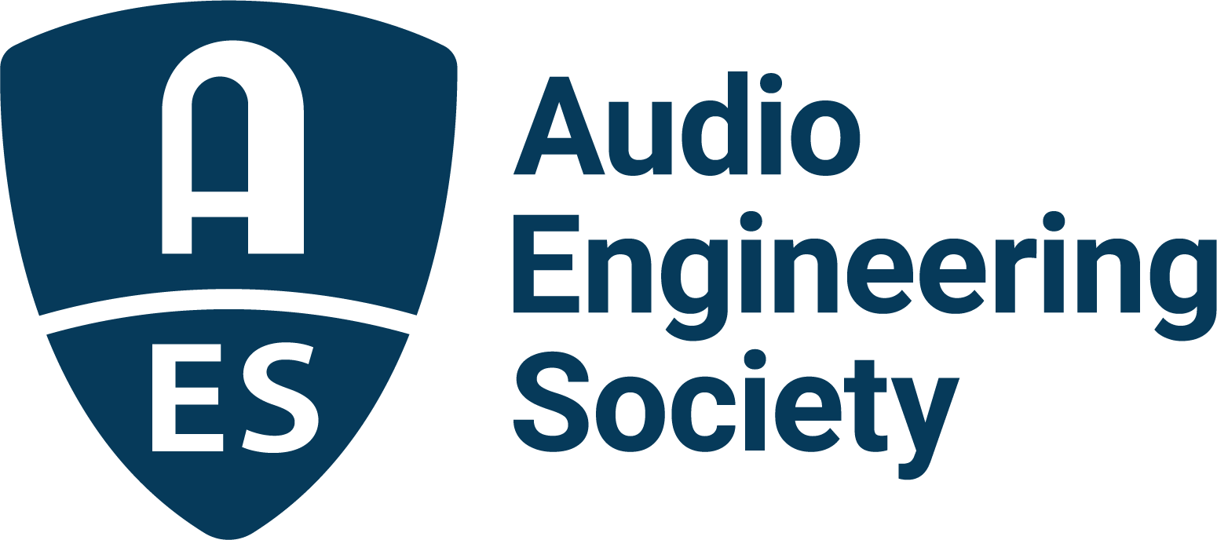

FOR IMMEDIATE RELEASE

AES Show 2025 to present “Studio Emergency Preparation” panel

— Panel to address operational disruptions, natural disasters, and proactive strategies for protecting studios and archives —

New York, NY, October 7, 2025 — The Audio Engineering Society (AES) announces an essential panel discussion to be held at the upcoming AES Show 2025 in Long Beach: “Studio Emergency Preparation.” Moderated by Maureen Droney, Vice President of the Recording Academy Producers & Engineers Wing®, the panel will feature insights from Anna Frick, mastering engineer and preservation advocate; Cheryl Pawelski, four-time GRAMMY® Award winner and veteran preservationist with over 30 years of experience; and Tracy Wronoski, Vice President at Gallagher and Director of The Recording Studio Insurance Program. This session addresses a critical challenge for today’s recording professionals: how to prepare for, and respond effectively to, operational disruptions, climate-related and natural disasters. The event will take place on Friday, October 24, 2025, from 1:15 p.m. to 2:15 p.m. PDT.

Recent fires in Los Angeles and devastating floods from Hurricane Helene in North Carolina serve as stark reminders that climate-related emergencies are no longer rare occurrences but growing realities. For recording studios, archives and music creators, these events can mean catastrophic losses of creative work, equipment and livelihood. This panel will provide attendees with actionable strategies to help protect their studios and content before disaster strikes and offer resources for navigating recovery in the aftermath.

“Studios are more than workplaces; they are creative sanctuaries and often financial lifelines,” said Maureen Droney. “Our goal is to equip music creators, studio owners and engineers with practical tools to protect those spaces and recover quickly when the unexpected happens.”

Anna Frick added, “As engineers and archivists, we have a responsibility not just to the artists we work with, but to the music itself. With climate change intensifying, preparation is essential to safeguard the creative legacies entrusted to us.”

The discussion will highlight the Recording Academy’s forthcoming publication, Studio Emergency Preparation Recommendations. Inspired by Frick, and developed by the Producers & Engineers Wing of the Recording Academy, this comprehensive new guide is designed to help recording professionals prepare for natural disasters, unforeseen emergencies and business interruptions. The document offers a range of resources, including a Quick Reference Guide Worksheet for capturing essential studio and emergency information, a concise one-sheet of everyday safety tips, and detailed instructions on risk assessment, hazard-specific planning and insurance considerations. It also addresses business continuity strategies such as remote work and emergency communications, while providing valuable information on post-disaster aid programs like MusiCares®, FEMA assistance and SBA disaster relief loans. Drawing on FEMA guidelines, insights from insurance experts and real-world experiences from working studio professionals, the guide and panel together provide an invaluable framework for reducing downtime, protecting assets and ensuring continuity in the face of emergencies.

“For more than three decades, I’ve seen how fragile our recorded legacies can be,” said Cheryl Pawelski. “Preparation isn’t optional, it’s essential. By planning ahead, we give ourselves the best chance to preserve not only the music, but the stories and cultural identity that come with it.”

Tracy Wronoski echoed Pawelski’s thoughts: “Preparation starts with understanding the unique risks that each recording studio faces and making sure those are addressed in advance,” stated Tracy Wronoski. “Having an insurance plan shaped by someone who knows the specific challenges of studio operations and equipment can make a real difference. Our role is to help studio owners be ready, supported, and able to recover quickly when unexpected events occur.”

The “Studio Emergency Preparation” panel will be held at AES Show 2025 in Long Beach, CA (Friday, October 24, 2025, from 1:15 p.m. to 2:15 p.m. PDT). Attendees will walk away with an understanding of risk-mitigation strategies, recovery resources, and a first look at the Recording Academy’s Studio Emergency Preparation Recommendations.

Photo File 1: PE_Studio_Emergency.JPG
Photo Caption 1: The Recording Academy P&E Wing has announced Studio Emergency Preparation Recommendations, a comprehensive new resource designed to help recording professionals prepare for natural disasters, unforeseen emergencies and business interruptions.

About the Audio Engineering Society
For more than 75 years, the Audio Engineering Society has served as the pivotal force in fostering the advancement in audio technologies and application and the dissemination of technical information for the audio community. Its members are affiliated with 90 AES professional sections and more than 120 AES student sections around the world where activities include guest speakers, technical tours, demonstrations, online events and social functions. Through Conventions, Conferences, Training and Development events and peer-reviewed publications, as well as the Society’s vast online technical documents, Standards and video resources, members experience valuable opportunities for professional networking and personal growth. For additional information, visit AES.org.

Join the conversation and keep up with the latest AES News and Events:
X: #AESorg (AES Official)
Facebook: facebook.com/AES.org
LinkedIn: https://www.linkedin.com/company/audio-engineering-society
Instagram: https://www.instagram.com/aes_org/

AES Marketing Communications:
Email: robert@clynemedia.com
Tel: 615-662-1616
Clyne Media, Inc.,
169-B Belle Forest Circle, Nashville, TN 37221;
Web: http://www.clynemedia.com

